**Answers-WEEK 29**

**I/ Look and match.**

**Cookie drink banana sandwich lunchbox**

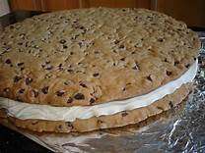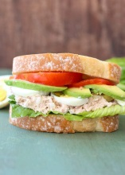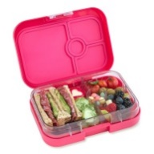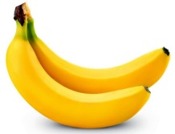

**II/ Complete the sentence.**

2/ don’t have

3/ have

4/ don’t have

5/ don’t have

6/ have

**III/ Look and write.**

2/ drink

3/ orange

4/ apple

5/ sandwiches

6/ lunchbox

7/ grapes

8/cookie

**IV/ Write.**

1/ cookie

2/ peach

3/ sandwich

4/ grapes

**V/ Underline the correct word.**

2/ two

3/ three

4/ an

5/ four

6/ a

**VI/ Write.**

2/ I have an orange

3/ I don’t have an apple.

4/ I have lemon juice.

5/ I don’t have a cookie.